1. 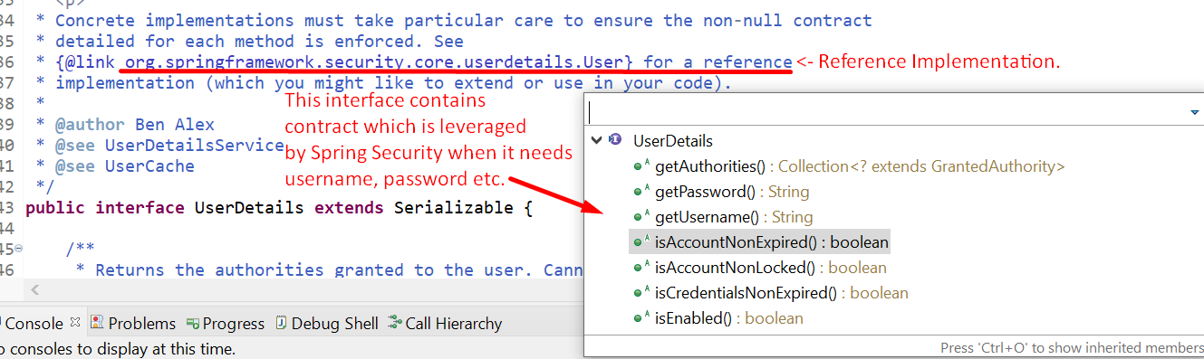
2. 
3. 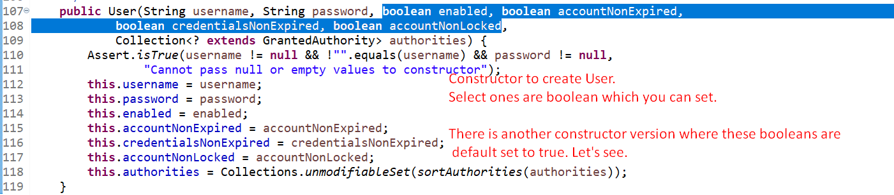
4. 
5. 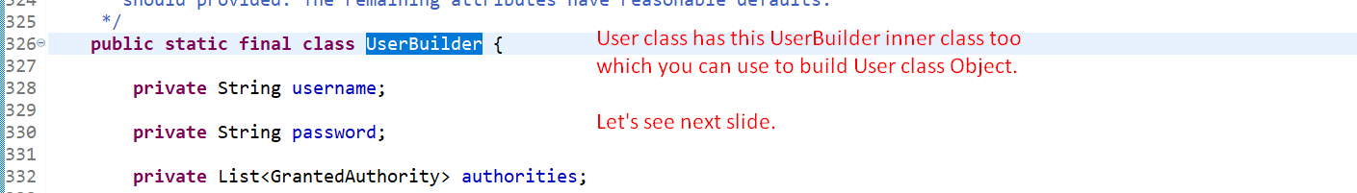
6. 
7. **NOTE**:  
   If not satisfied with the default implementation (User) for UserDetails, then create your own class by implementing UserDetails.   
   